Introduction
To begin this task, I downloaded and installed the WEKA datamining software. I launched the WEKA GUI Chooser, opened the 'Explorer' interface, and navigated to the 'Preprocess' tab. From there, I opened the folder containing the preinstalled datasets and loaded my first chosen dataset: iris.arff. I then navigated to the 'Classify' tab to begin testing the six required algorithms.

Iris Section

Naïve Bayes
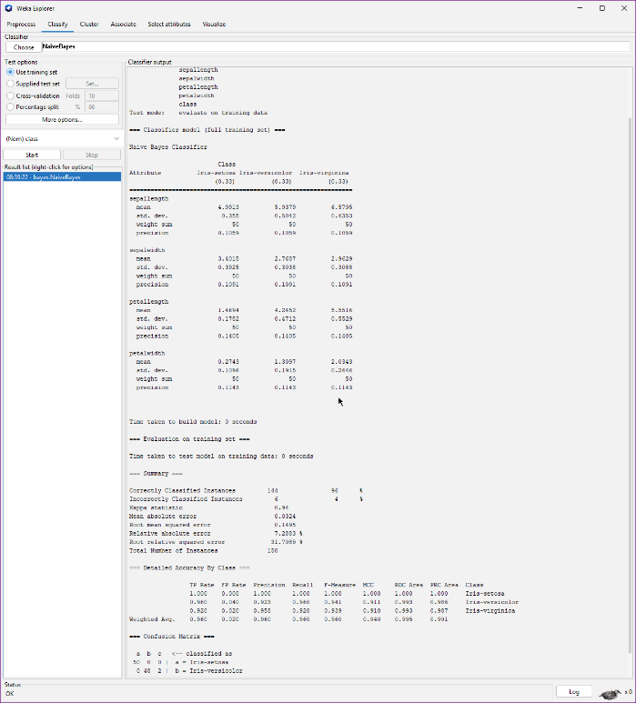
Figure 1: Naïve Bayes, Use Training Set
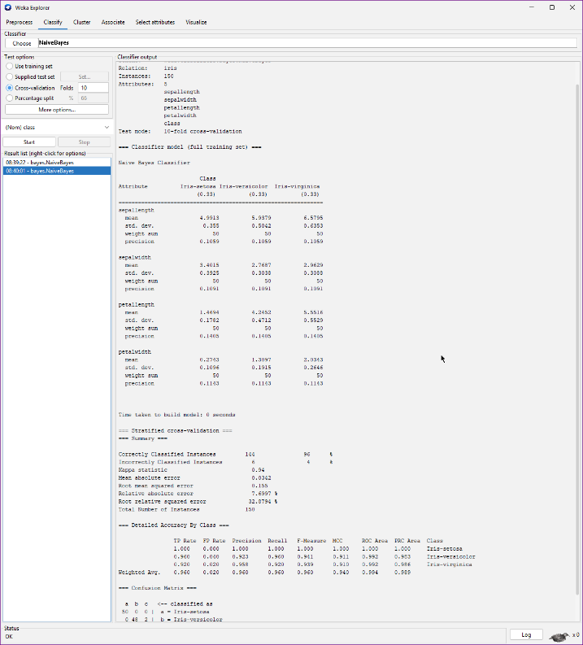
Figure 2: Naïve Bayes, Cross-validation (10 Folds)
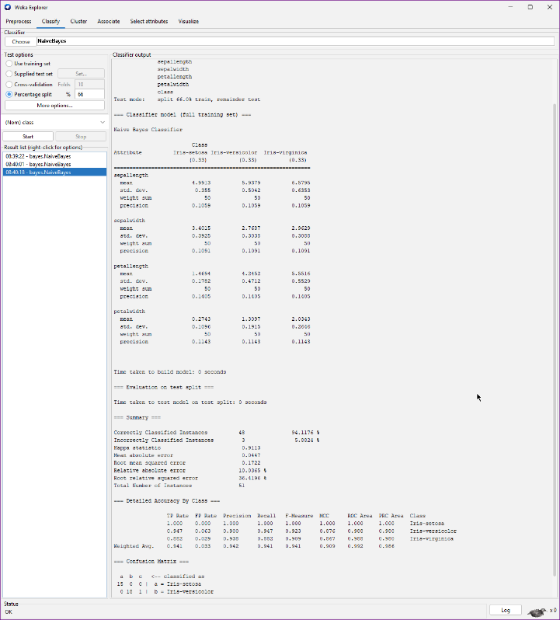
Figure 3: Naïve Bayes, Percentage Split (80%)

Logistic Regression
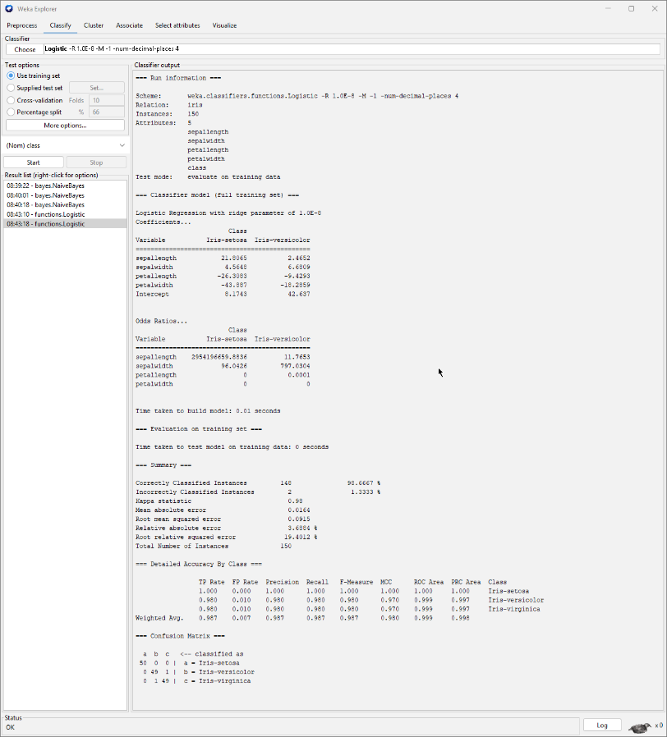
Figure 4: Logistic Regression, Use Training Set

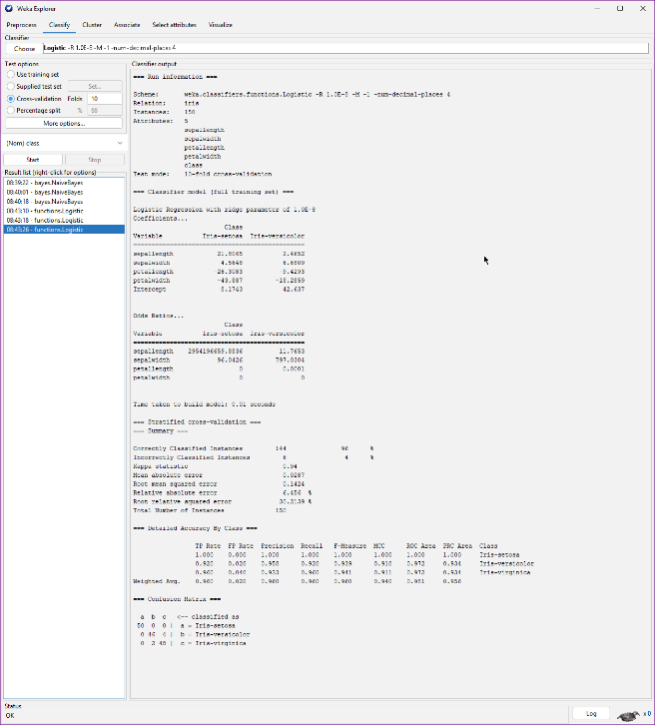
Figure 5: Logistic Regression, Cross-validation (10 Folds)
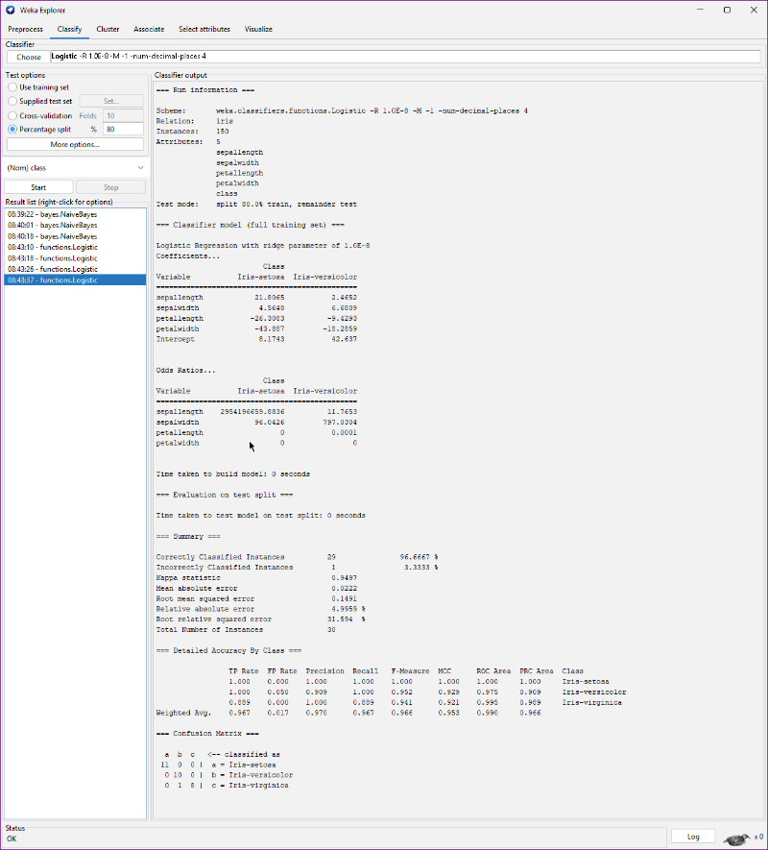
Figure 6: Logistic Regression, Percentage Split (80%)

SMO
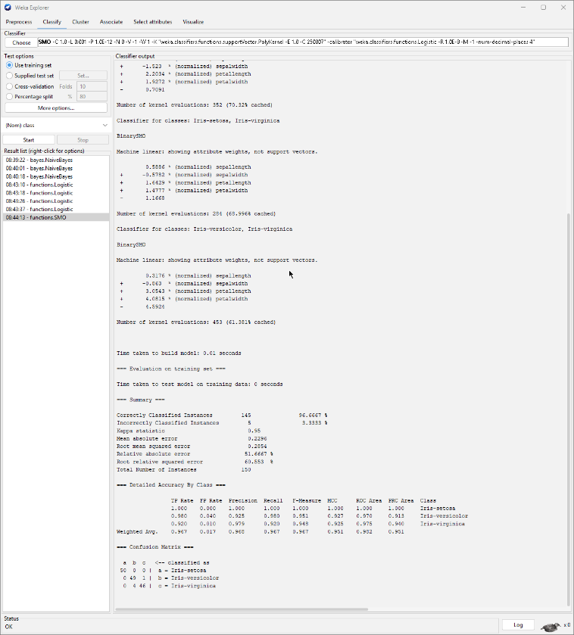
Figure 7: SMO, Use Training Set

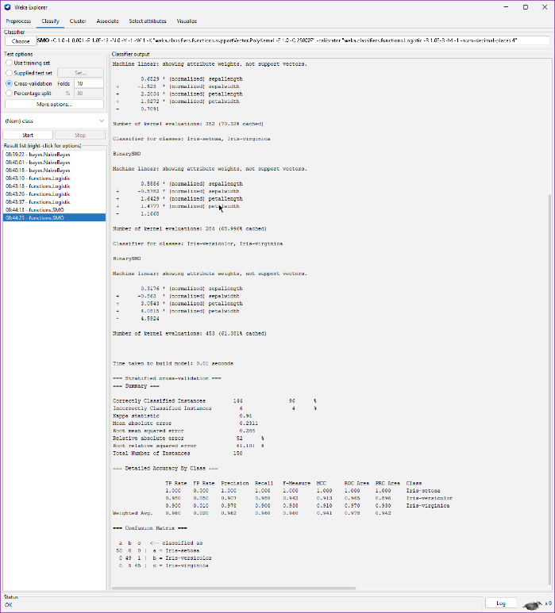
Figure 8: SMO, Cross-validation (10 Folds)
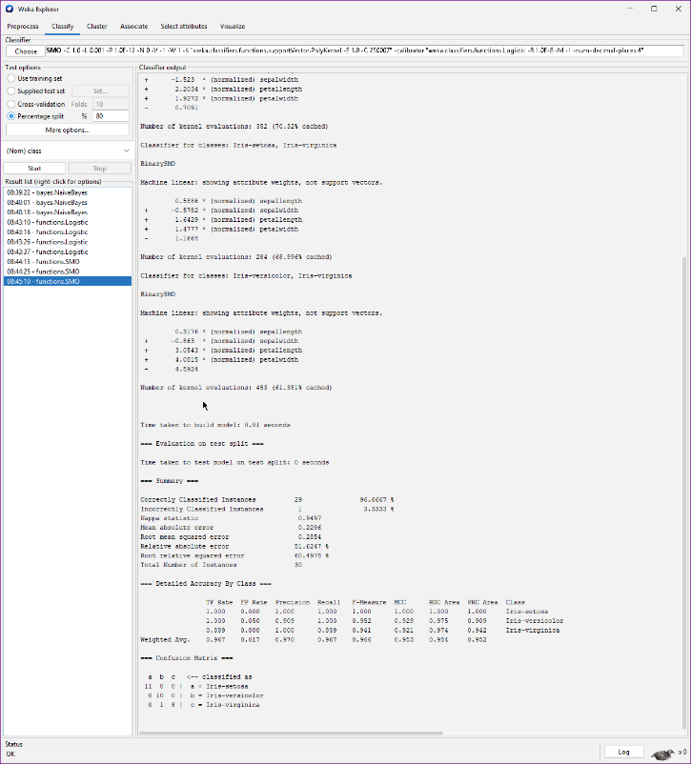
Figure 9: SMO, Percentage Split (80%)

K-Nearest Neighbor
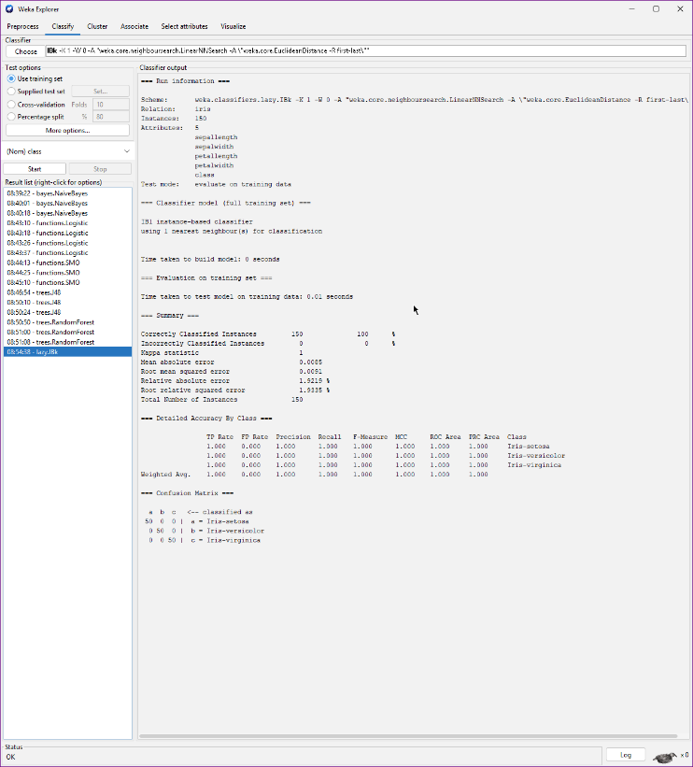
Figure 10: K-Nearest Neighbor, Use Training Set

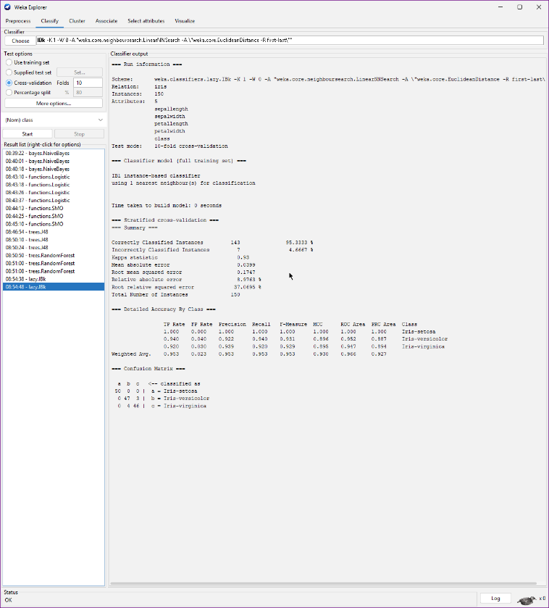
Figure 11: K-Nearest Neighbor, Cross-validation (10 Folds)

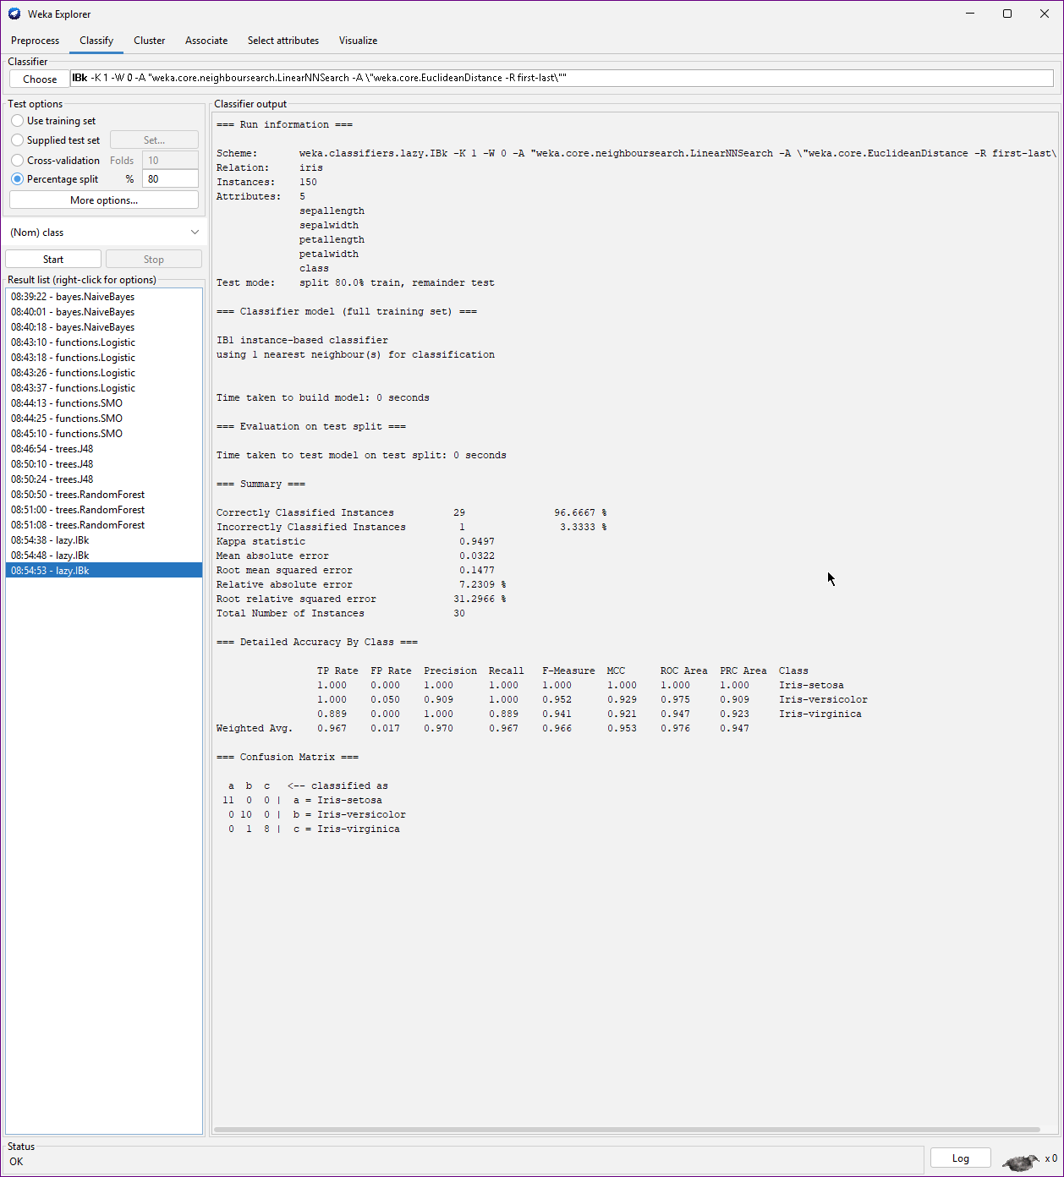
Figure 12: K-Nearest Neighbor, Percentage Split (80%)

J48
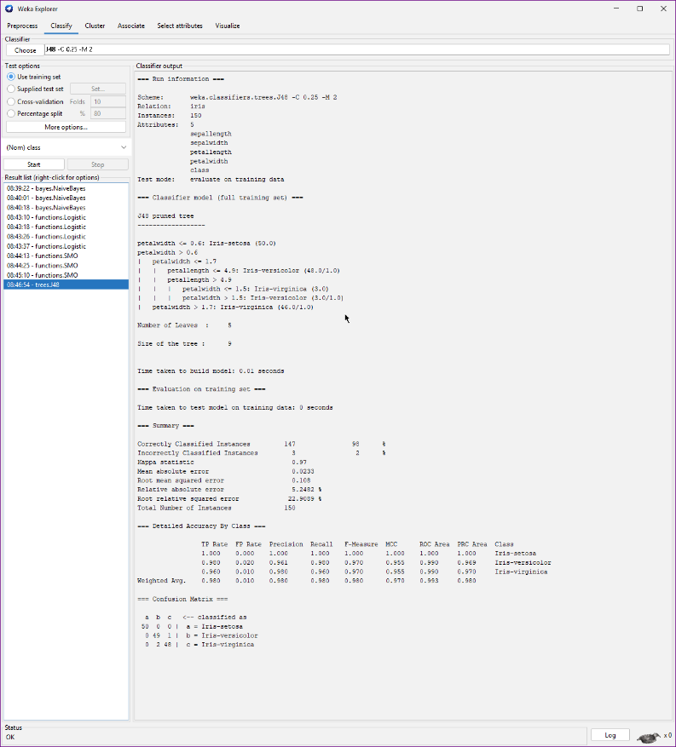
Figure 13: J48, Use Training Set
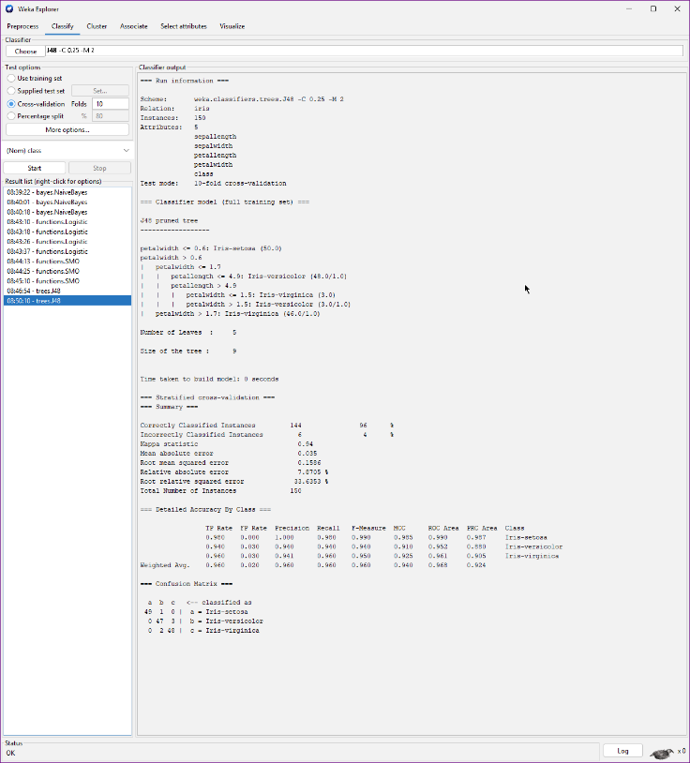
Figure 14: J48, Cross-validation (10 Folds)

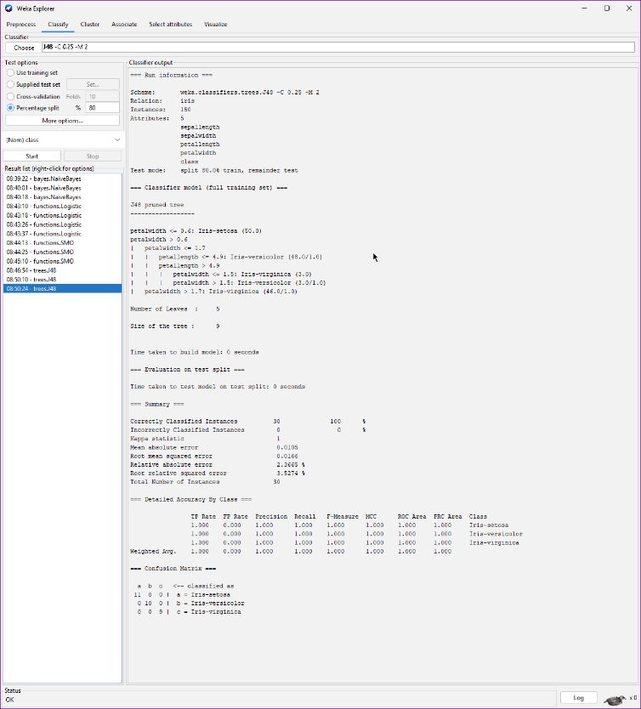
Figure 15: J48, Percentage Split (80%)

Random Forest
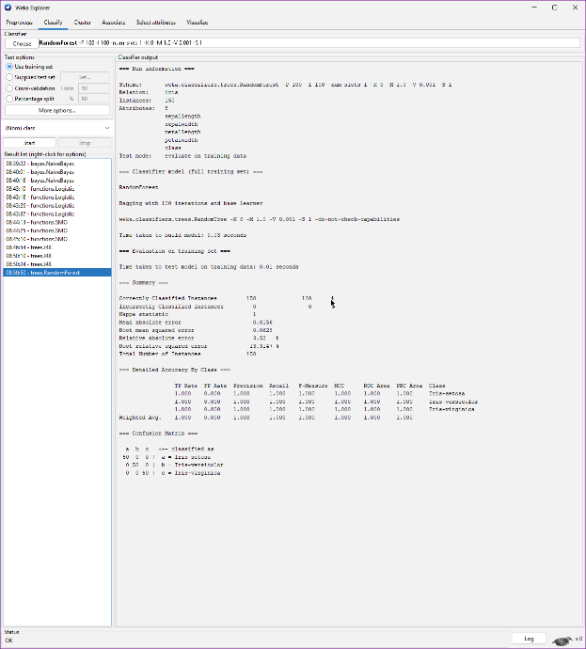
Figure 16: Random Forest, Use Training Set
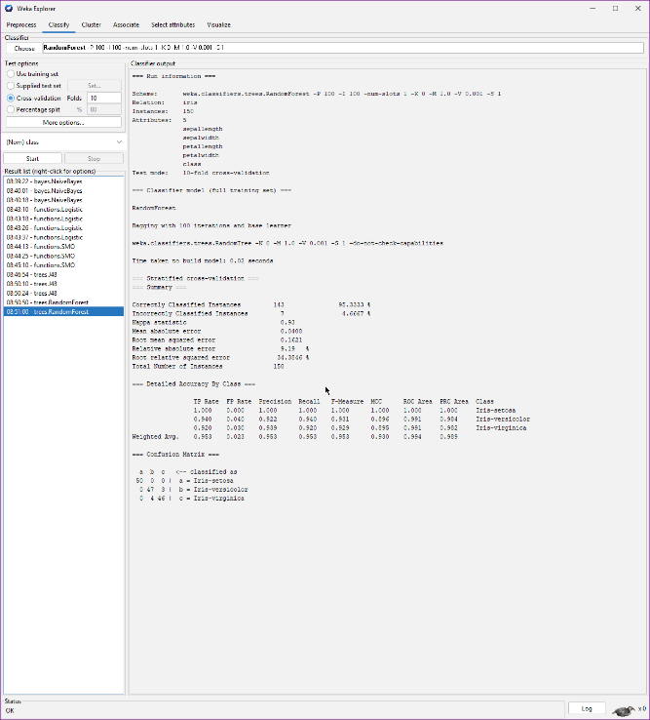
Figure 17: Random Forest, Cross-validation (10 Folds)

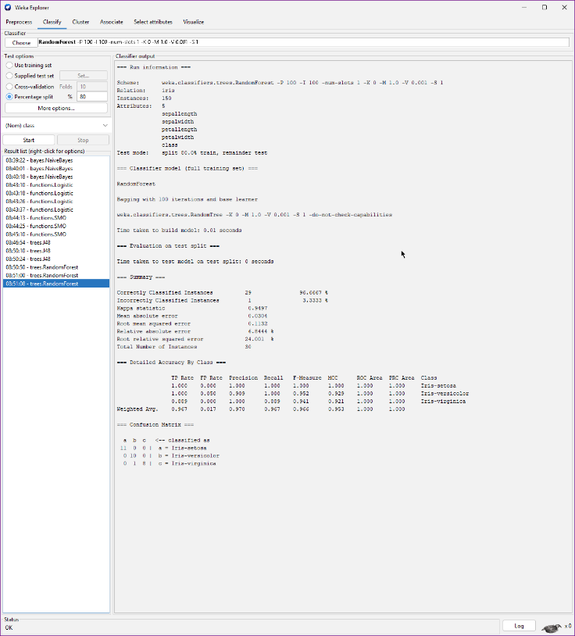
Figure 18: Random Forest, Percentage Split (80%)

Diabetes Section
After completing the algorithm tests for the Iris data, I returned to the 'Preprocess' tab, cleared the workspace, and loaded my second preinstalled dataset: diabetes.arff. I then repeated the classification process.

Naïve Bayes
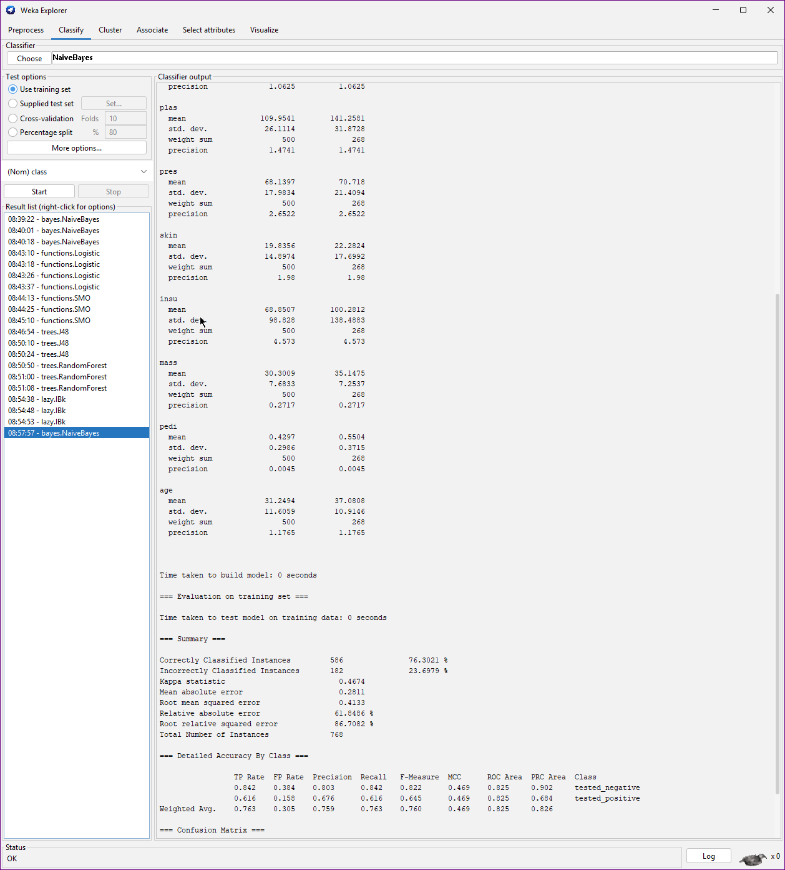
Figure 19: Naïve Bayes, Use Training Set
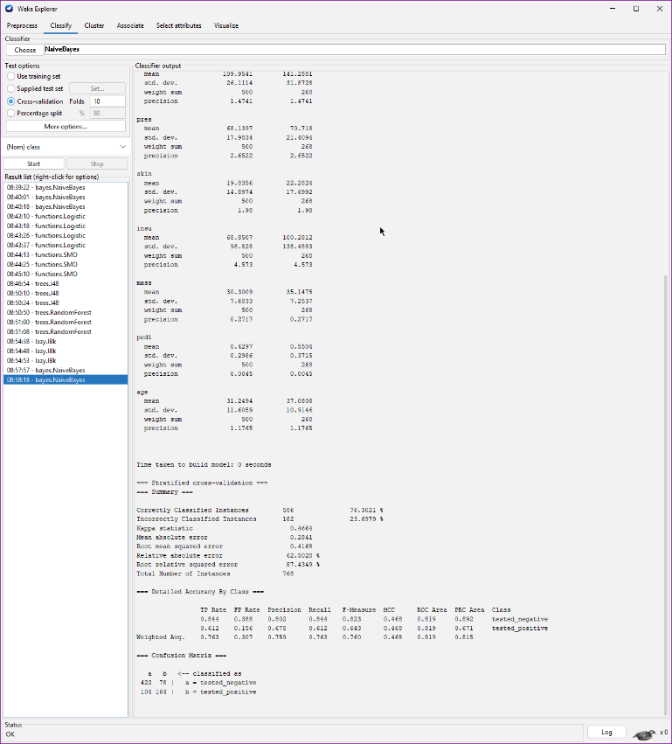
Figure 20: Naïve Bayes, Cross-validation (10 Folds)

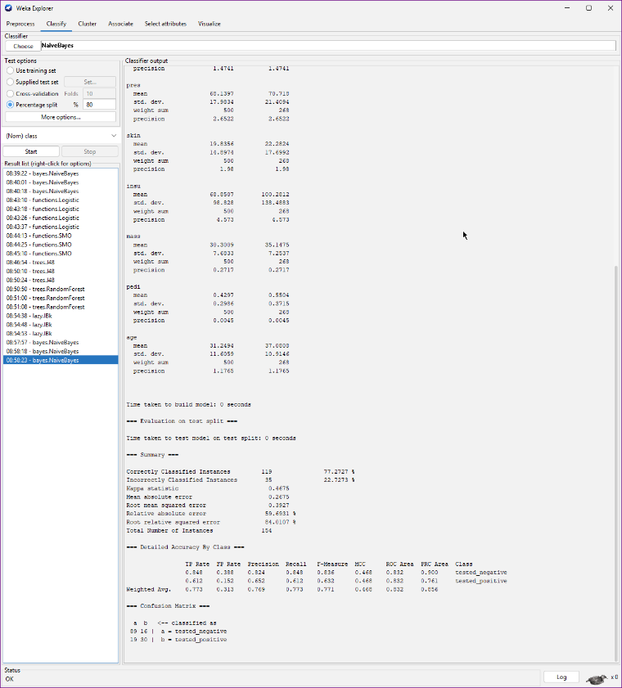
Figure 21: Naïve Bayes, Percentage Split (80%)

Logistic Regression

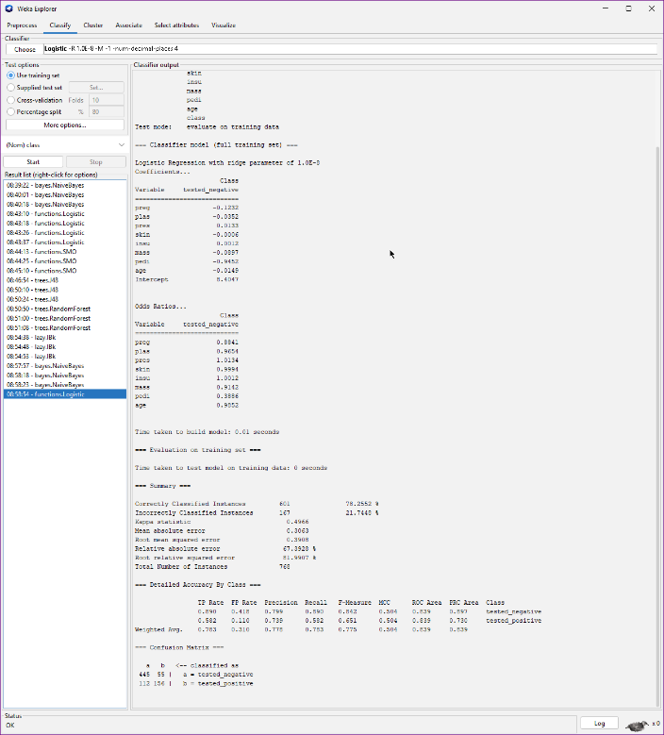
Figure 22: Logistic Regression, Use Training Set
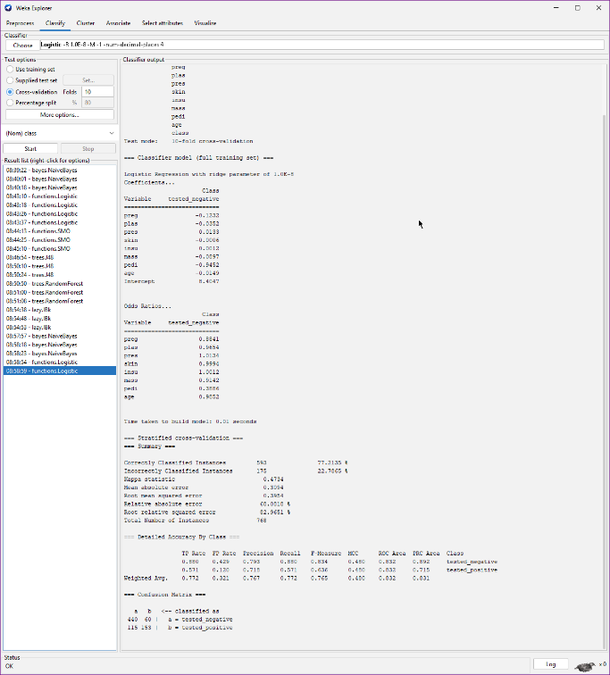
Figure 23: Logistic Regression, Cross-validation (10 Folds)

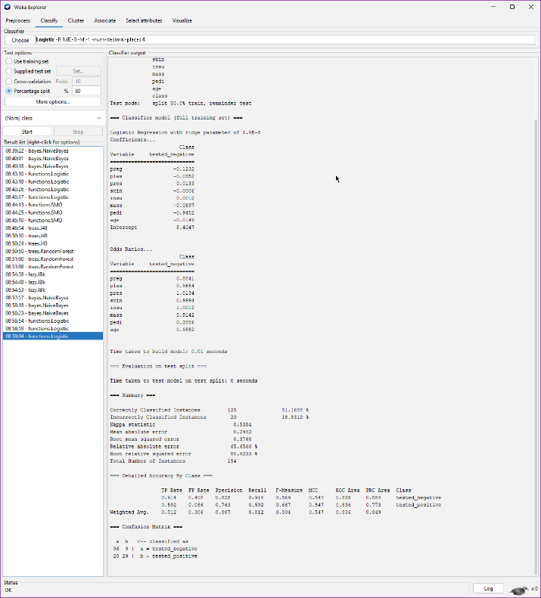
Figure 24: Logistic Regression, Percentage Split (80%)

SMO
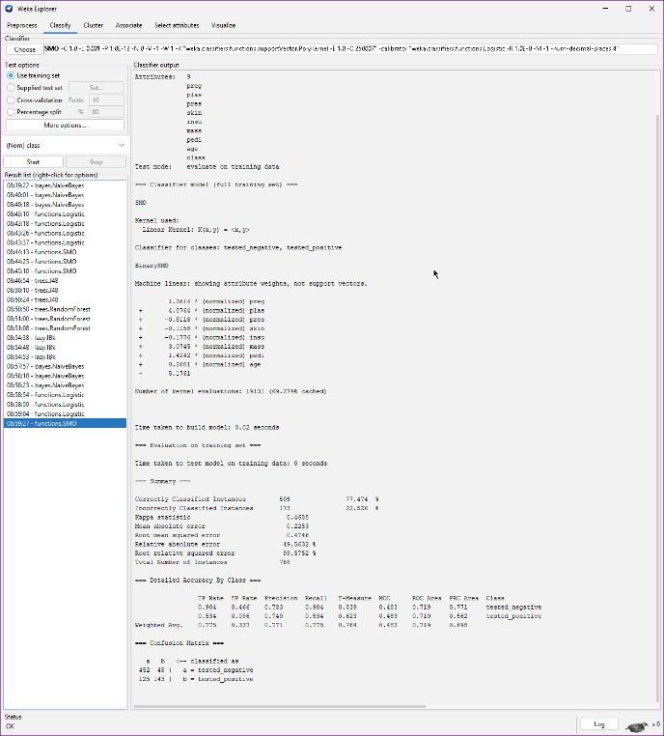
Figure 25: SMO, Use Training Set
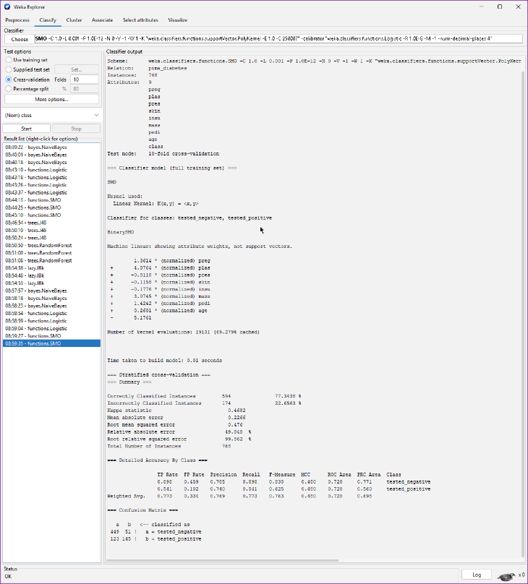
Figure 26: SMO, Cross-validation (10 Folds)

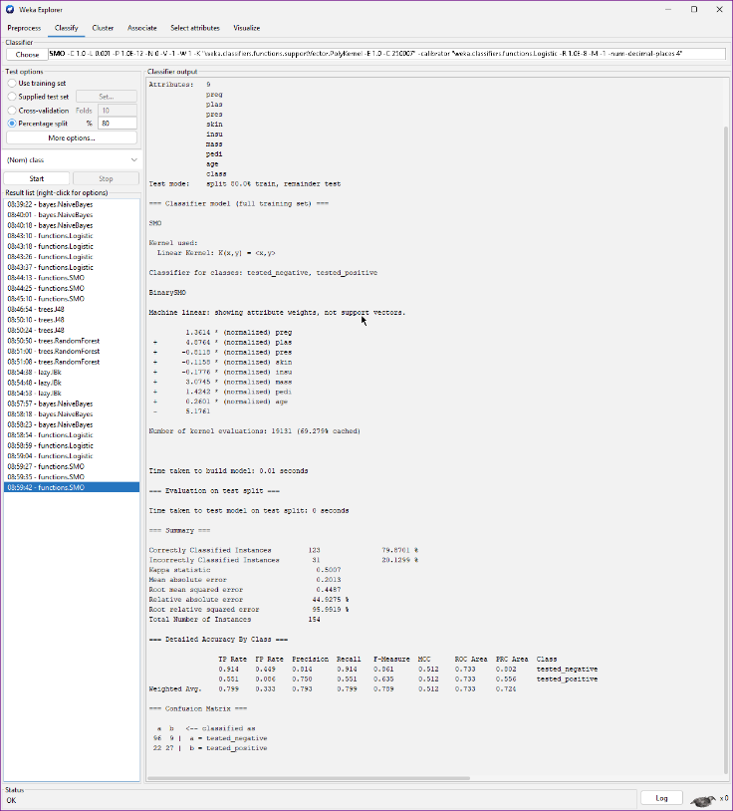
Figure 27: SMO, Percentage Split (80%)

K-Nearest Neighbor
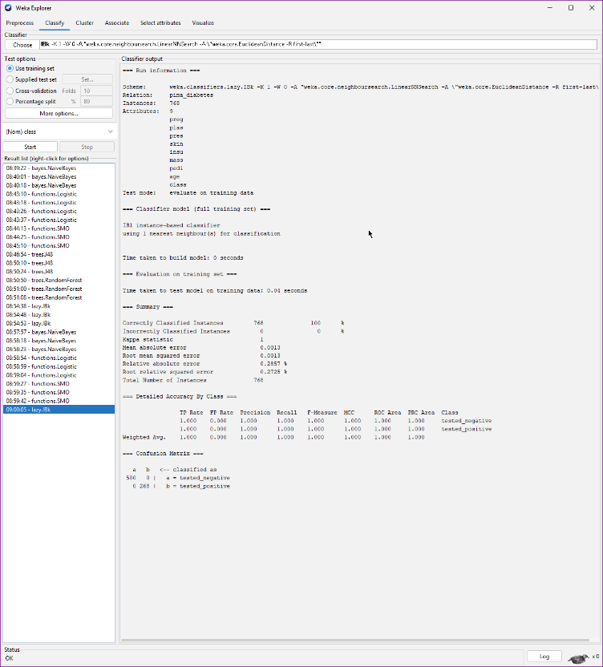
Figure 28: K-Nearest Neighbor, Use Training Set
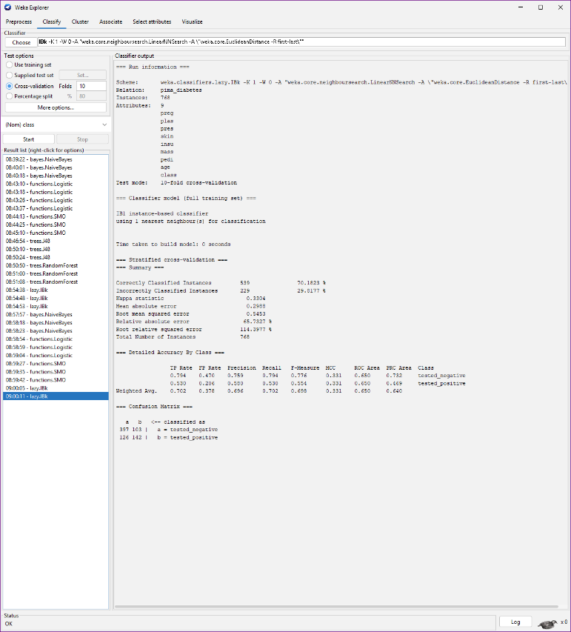
Figure 29: K-Nearest Neighbor, Cross-validation (10 Folds)
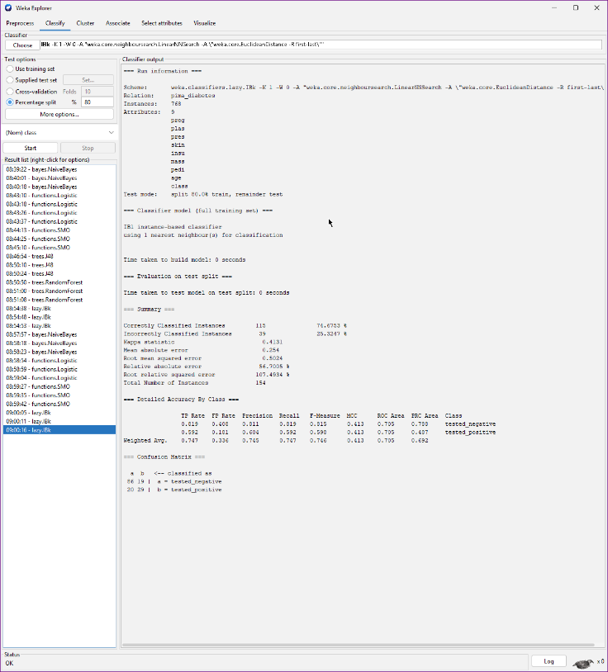
Figure 30: K-Nearest Neighbor, Percentage Split (80%)

J48
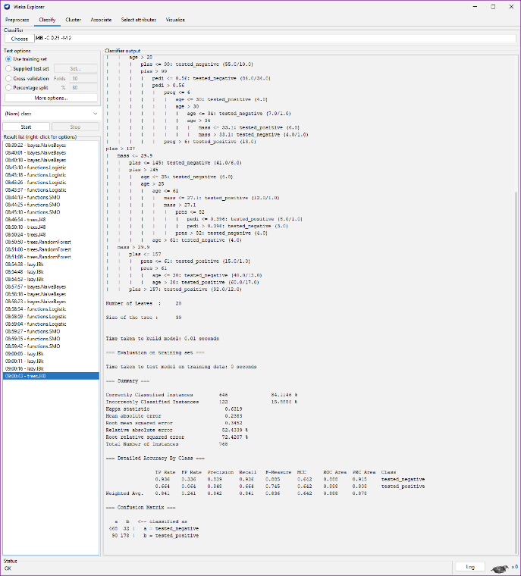
Figure 31: J48, Use Training Set
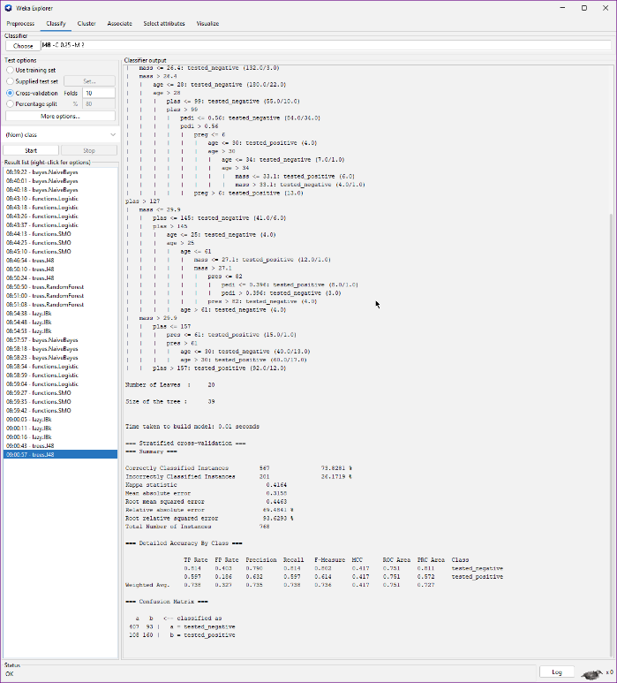
Figure 32: J48, Cross-validation (10 Folds)

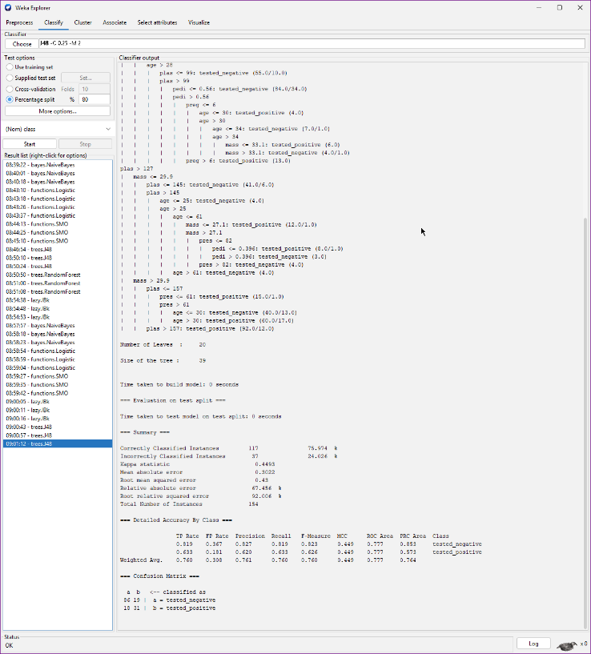
Figure 33: J48, Percentage Split (80%)

Random Forest
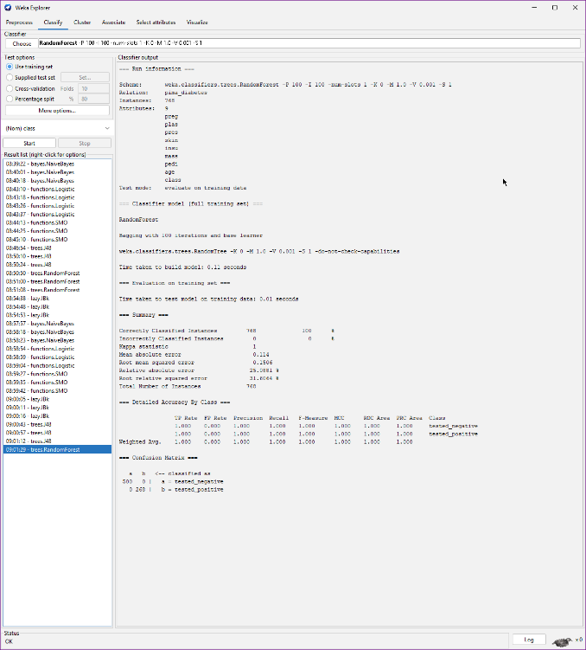
Figure 34: Random Forest, Use Training Set

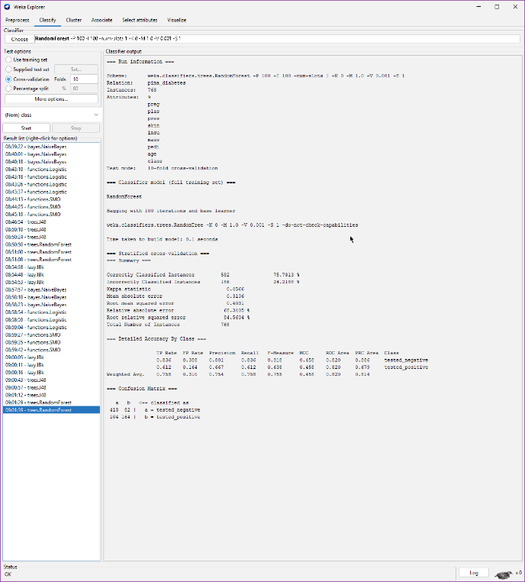
Figure 35: Random Forest, Cross-validation (10 Folds)

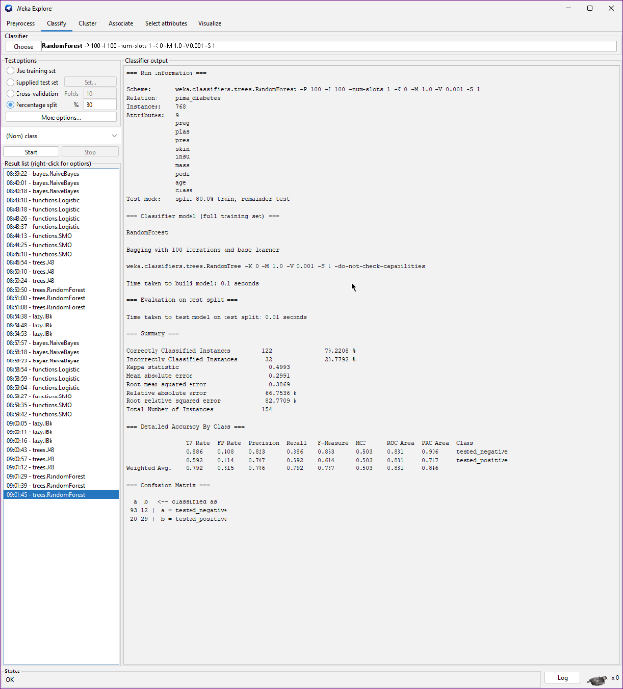
Figure 36: Random Forest, Percentage Split (80%)

Final Analysis
To determine the best algorithm for each dataset, I evaluated the "Weighted Avg." row within the "Detailed Accuracy By Class" table on the 10-fold cross-validation tests. Specifically, I prioritized the F-Measure column (which provides a mathematically balanced metric of Precision and Recall) and the ROC Area column (which measures the model's ability to distinguish between classes). I cross-referenced these metrics with the overall "Correctly Classified Instances" percentage at the top of the summary.

Best Algorithm by Dataset:
Iris Dataset: The best algorithms are SMO and Logistic Regression. Both achieved the highest overall accuracy (96%) and the highest Weighted Avg. F-Measure. Because the Iris dataset is largely linearly separable, these algorithms excel at finding precise boundaries without overfitting.
Diabetes Dataset: The best algorithm is Logistic Regression. While its raw accuracy was nearly tied with SMO, Logistic Regression heavily outperformed all other algorithms with the highest Weighted Avg. ROC Area and the highest Weighted Avg. F-Measure, making it the most reliable model for distinguishing between the medical classifications.

